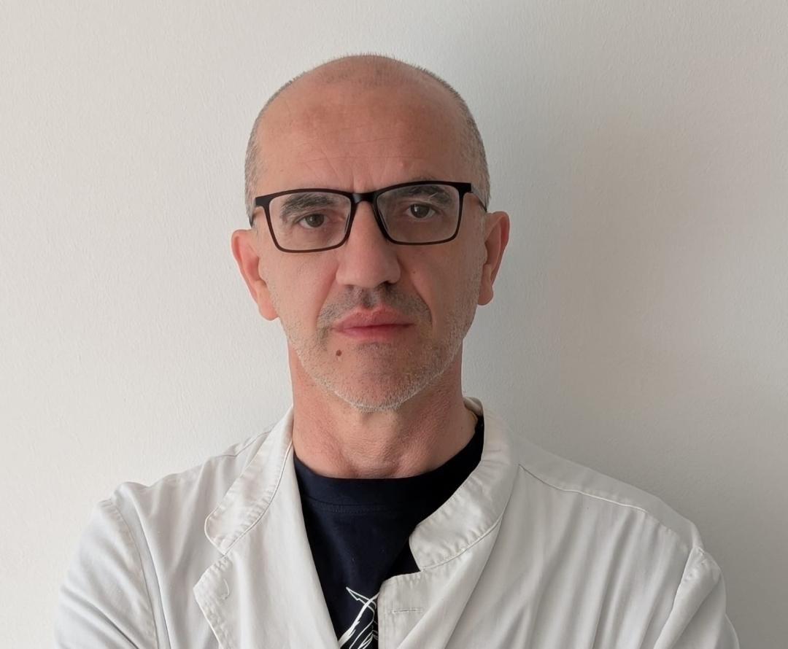

Short CV – Nikola Knežević
Prof. Dr. Nikola Knežević is a urologist and associate professor at the School of Medicine, University of Zagreb and the Department of Urology, University Hospital Centre Zagreb. Currently, he serves as the Head of the Department of Endourology at the Urology Clinic. He received postgraduate training in Austria (Innsbruck and Linz), robotic education in Milan and Zagreb, and participated in advanced workshops and education across Europe. His notable achievements include first experiences and publications related to the use of the Senhance robotic system in urology, as well as innovations in the use of lasers for partial nephrectomies. Dr. Knežević is a member of several professional urology societies and the incumbent Vice-President of the European Centre for Rare Adrenal Diseases (ERN eUROGEN). He participated in several scientific projects, mainly in the field of reproductive medicine and published numerous peer-reviewed scientific papers, with an emphasis on robotics in urology and minimally invasive methods. Prof. Knežević actively lectured at international conferences (China, Montenegro, Slovenia, Bosnia and Herzegovina) and was the organiser and co-organiser of numerous scientific and professional congresses.

