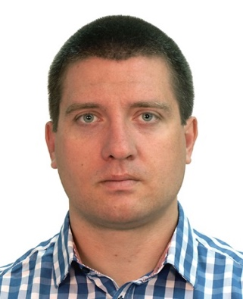
Milan Milosevic, MD, PhD
Associate Professor
Specialist in Occupational and Sports Medicine
University of Zagreb, School of Medicine
Andrija Štampar School of Public Health
Rockefellerova 4, 10000 Zagreb, Croatia
E-mail: milan.milosevic@snz.hr

Associate Professor Milan Milosevic was born in 1980 in Zadar, Croatia. He studied at the University of Zagreb School of Medicine from 1998 to 2004 and graduated as a medical doctor, among the top 10% of students. From 2006 to 2010, he was a resident in occupational and sports medicine, and in 2011 he became a specialist in occupational and sports medicine. In 2010, he defended his doctoral dissertation entitled "Development and evaluation of a measurement tool for perceived stressors in the workplace among hospital healthcare workers" at the School of Medicine, University of Zagreb. In 2015, he became an assistant professor, and in 2020 an associate professor of occupational and sports medicine at the School of Medicine, University of Zagreb. He has actively participated in several national and international projects in occupational and sports medicine and has participated in numerous domestic and international workshops and trainings.
Milan Milosevic is the Head of the Department of Environmental Health and Occupational and Sports Medicine, a member of the Board of Directors of the Croatian Society for Occupational Health, Vice-President of the Croatian Society for Sports Medicine and co-head of the postgraduate specialist study of Occupational and Sports Medicine and holds the position of Acting Director of the Student Polyclinic - STUP of the School of Medicine University of Zagreb. He is a member of the Anti-Doping Advisory Committee of the Anti-Doping Service of the Croatian Institute of Public Health and the National Anti-Doping Commission. As part of the Croatian mission and team doctor, he participated in the Paralympic Games in Paris 2024.
Milan Milosevic is the author of more than 200 scientific papers, of which more than 100 have been published in journals indexed in the Web of Science Core Collection. It has been cited more than 5,500 times (Google Scholar, July 2025). Scientific interests are occupational and sports medicine, doping and sports supplementation, biostatistics, reproductive health, risk assessment, mental health and parasport. He is a reviewer in several scientific and professional journals. He is married, father of four children, and in his free time he actively participates in hiking, cycling, playing the guitar and singing in the men's choir.

