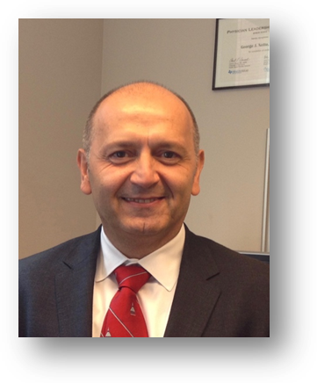
George Jabboure Netto, M.D.
Professor and Chair of Pathology
The University of Alabama at Birmingham
Birmingham, Alabama 35249
USA
mailto:gnetto@UABMC.edu

George J. Netto, M.D. is Professor and Chair of Pathology at The University of Alabama at Birmingham (UAB). Prior to joining UAB, Dr. Netto was a Professor of Pathology, Urology and Oncology at Johns Hopkins University where he served as the director of Surgical Pathology Molecular Diagnostics. He received his medical degree from the Damascus University Faculty of Medicine in Syria followed by his residency training in Pathology at Baylor University Medical Center in Dallas, Texas. Directly following, he pursued a postdoctoral fellowship in Anatomic Pathology at the Washington University School of Medicine and the Ackerman’s Laboratory of Pathology at Barnes Hospital in St. Louis, Missouri. Dr. Netto then completed a postdoctoral fellowship in Urologic Pathology at the Memorial Sloan Kettering Cancer Center in New York City.

Dr. Netto is recognized throughout the United States and around the globe for his expertise as a clinician, scholarly educator, and physician-scientist whose research is focused on urologic and molecular diagnostic pathology. He is associate editor of the Vircow Archives European Journal od Pathology , associate editor for translation and basic science for the journal “Urology” and the associate editer for the journal “Urology Case Report” and serves on the editorial boards of the journals of “Human Pathology”, “Pathology” and “Advances in Anatomic Pathology”. He has authored or co-authored more than 280 articles which have been published in peer-reviewed medical journals. He has co-authored four books in urologic pathology and is the editor of a widely recognized textbook on genomics in pathology titled “Genomic Applications in Pathology”. Dr. Netto is frequently requested to speak at national and international lectures in the fields of urologic oncology and molecular and genomic diagnostics.

